Experiment 2 – Cascading Style Sheets and JavaScript

Objective
- Introduction to CSS (Cascading Style sheets)
- Apply CSS to your html page
- Client side validation and learn how to apply client validation using JavaScript

At the end of this lab you will be able to

- Create CSS style sheet and Apply CSS
- Create and use JavaScript functions
- Apply Client side validations

What is CSS?
CSS stands for Cascading Style Sheets
Styles define how to display HTML elements
Styles were added to HTML 4.0 to solve a problem
External Style Sheets can save a lot of work
External Style Sheets are stored in CSS files

Why we needed CSS?
HTML was never intended to contain tags for formatting a document.HTML was intended to define the content of a document, like:
<h1>This is a heading</h1>
<p>This is a paragraph.</p>
When tags like <font>, and color attributes were added to the HTML 3.2 specification, it started a nightmare for web developers. Development of large web sites, where fonts and color information were added to every single page, became a long and expensive process.
To solve this problem, the World Wide Web Consortium (W3C) created CSS.
CSS defines HOW HTML elements are to be displayed.
Styles are normally saved in external .css files. External style sheets enable you to change the appearance and layout of all the pages in a Web site, just by editing one single file!

CSS Syntax
A CSS rule has two main parts: a selector, and one or more declarations:
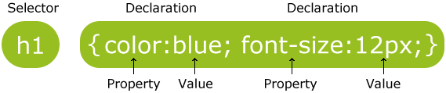
The selector is normally the HTML element you want to style.
Each declaration consists of a property and a value.
The property is the style attribute you want to change. Each property has a value.

In addition to setting a style for a HTML element, CSS allows you to specify your own selectors called "id" and "class".
Id Selector Syntax
The id selector is used to specify a style for a single, unique element.
The id selector uses the id attribute of the HTML element, and is defined with a "#".
The style rule below will be applied to the element with id="para1":

#para1
{
text-align:center;
color:red;
}

Class Selector Syntax
The class selector is used to specify a style for a group of elements. Unlike the id selector, the class selector is most often used on several elements.
This allows you to set a particular style for many HTML elements with the same class. The class selector uses the HTML class attribute, and is defined with a "."
In the example below, all HTML elements with class="center" will be center-aligned:

.center {text-align:center;}

How to apply CSS
There are three ways of inserting a style sheet:
- External style sheet
- Internal style sheet
- Inline style

External Style sheet
An external style sheet is ideal when the style is applied to many pages. With an external style sheet, you can change the look of an entire Web site by changing one file. Each page must link to the style sheet using the <link> tag. The <link> tag goes inside the head section:
<head>
<link rel="stylesheet" type="text/css" href="mystyle.css"/>
</head>
An external style sheet can be written in any text editor. The file should not contain any html tags. Your style sheet should be saved with a .css extension. An example of a style sheet file is shown below:
p {margin-left:20px;}
body {background-image:url("images/back40.gif");}

Internal Style sheet
An internal style sheet should be used when a single document has a unique style. You define internal styles in the head section of an HTML page, by using the <style> tag, like this:
<head>
<style>
p {margin-left:20px;}
body {background-image:url("images/back40.gif");}
</style>
</head>
Inline Style sheet
An inline style loses many of the advantages of style sheets by mixing content with presentation. Use this method sparingly!
To use inline styles you use the style attribute in the relevant tag. The style attribute can contain any CSS property. The example shows how to change the color and the left margin of a paragraph:
<p style="color:sienna; margin-left:20px">This is a paragraph.</p>

Exercise 1: Practice applying CSS to HTML pages
Example

body
{
background-color:#d0e4fe;
}
h1
{
color:orange;
text-align:center;
}
p
{
font-family:"TimesNewRoman";
font-size:20px;
}
.myclass
{
font-family:"TimesNewRoman";
font-size:20px;
}

Save the above in a style.css file and then apply in html as external style sheet by adding
<link href="style.css" rel="stylesheet" type="text/css" />
Please try all the selectors (given above) in your html e.g.<td class=”myclass”>

What is JavaScript?
- A scripting language is a lightweight programming language.
- JavaScript is programming code that can be inserted into HTML pages.
- JavaScript inserted into HTML pages, can be executed by all modern web browsers.

Usage of JavaScript
- Writing Into HTML Output
document.write("<h1>This is a heading</h1>");
- Reacting to Events
<button type="button" onclick="alert('Welcome!')">Click Me!</button>
- Changing HTML Content
x=document.getElementById("demo") //Find the element
x. innerHTML="Testing… “;
- Changing HTML Styles
x=document.getElementById("demo") //Find the element
x.style.color="#ff0000"; //Change the style
- Validate Input
var num=document.getElementById("demo") .value //demo is a textbox
if (num==null|| num==””)
{alert("Enter a value please")};

How to apply JavaScript
To insert a JavaScript into an HTML page, use the <script> tag.
The <script> and </script> tells where the JavaScript starts and ends.
There are two ways of inserting JavaScript:
  - Internal JavaScript
  - External JavaScript
Internal JavaScript
You can place an unlimited number of scripts in an HTML document.
Scripts can be in the <body> or in the <head> section of HTML, and/or in both.
It is a common practice to put functions in the <head> section, or at the bottom of the page. This way they are all in one place and do not interfere with page content.
<!DOCTYPE html>
<html>
<head>
<script language="javascript">
function myFunction()
{
document.getElementById("demo").innerHTML="My First JavaScript Function";
}
</script>
</head>
<body>
<h1>My Web Page</h1>
<p id="demo">A Paragraph</p>
<button type="button" onclick="myFunction()">Try it</button>
</body>
</html>
External JavaScript
Scripts can also be placed in external files. External files often contain code to be used by several different web pages.
External JavaScript files have the file extension .js.
To use an external script, point to the .js file in the "src" attribute of the <script> tag:
<!DOCTYPE html>
<html>
<body>
<script src="myScript.js" language="javascript"></script>
</body>
</html>

Exercise 2: Practice JavaScript
Write a JavaScript function to convert Celsius into Fahrenheit and vice versa in HTML using JavaScript on input controls

GUI should be like this

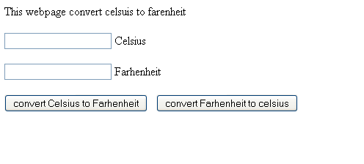

Exercise 3: Practice CSS and JavaScript

You are required to design a login web page that will have username and password text fields as shown below:

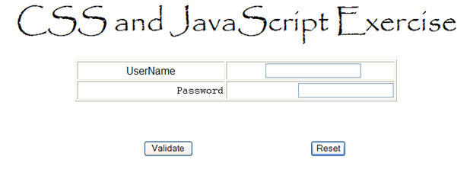
Requirements:

Default Setting (When the page is loaded)

1. Everything in the username field row must be center aligned with font = arial, using CSS
2. Everything in the password field row must be right aligned with font = courier, using CSS

On Validate button you need to do the following:
Check if anything has been entered in the username and password fields.

- If a field is empty then the background color of the whole row must be set to "RED".
- If a field is NOT empty then the background color of the whole row must be set to "YELLOW".

Post lab

Add the following feature in your exercise 3.

On Reset button you need to do the following:

Bring the page in the default state i.e. the state when page was loaded.

NOTE: You are required to use JavaScript and CSS to perform the above mentioned functionality.

